**WEEK-4**

**REST - Country Web Service**

Country.xml

<?xml version=*"1.0"* encoding=*"UTF-8"*?>

<beans xmlns=*"http://www.springframework.org/schema/beans"*

xmlns:xsi=*"http://www.w3.org/2001/XMLSchema-instance"*

xsi:schemaLocation=*"http://www.springframework.org/schema/beans*

*http://www.springframework.org/schema/beans/spring-beans.xsd"*>

<bean id=*"in"* class=*"com.cognizant.spring_learn.Country"*>

<property name=*"code"* value=*"IN"*/>

<property name=*"name"* value=*"India"*/>

</bean>

</beans>

Countrycontroller.java

package com.cognizant.spring_learn.controller;

import org.springframework.beans.factory.annotation.Autowired;

import org.springframework.context.ApplicationContext;

import org.springframework.context.support.ClassPathXmlApplicationContext;

import org.springframework.web.bind.annotation.RequestMapping;

import org.springframework.web.bind.annotation.RestController;

import com.cognizant.spring_learn.Country;

*@RestController*

public class CountryController {

*@RequestMapping*("/country")

public Country getCountryIndia() {

ApplicationContext context = new ClassPathXmlApplicationContext("country.xml");

Country country = (Country) context.getBean("in");

return country;

}

}

SpringLearnApplication.java

package com.cognizant.spring_learn;

import org.springframework.boot.SpringApplication;

import org.springframework.boot.autoconfigure.SpringBootApplication;

*@SpringBootApplication*(

exclude = {

org.springframework.boot.autoconfigure.jdbc.DataSourceAutoConfiguration.class,

org.springframework.boot.autoconfigure.orm.jpa.HibernateJpaAutoConfiguration.class

}

)

public class SpringLearnApplication {

public static void main(String[] args) {

SpringApplication.*run*(SpringLearnApplication.class, args);

System.***out***.println("App is running...");

}

}

Country.java

package com.cognizant.spring_learn;

import org.slf4j.Logger;

import org.slf4j.LoggerFactory;

public class Country {

private static final Logger ***LOGGER*** = LoggerFactory.*getLogger*(Country.class);

private String code;

private String name;

public Country() {

***LOGGER***.debug("Inside Country Constructor.");

}

public String getCode() {

***LOGGER***.debug("Inside getCode");

return code;

}

public void setCode(String code) {

***LOGGER***.debug("Inside setCode");

this.code = code;

}

public String getName() {

***LOGGER***.debug("Inside getName");

return name;

}

public void setName(String name) {

***LOGGER***.debug("Inside setName");

this.name = name;

}

*@Override*

public String toString() {

return "Country [code=" + code + ", name=" + name + "]";

}

}

OUTPUT

Browser

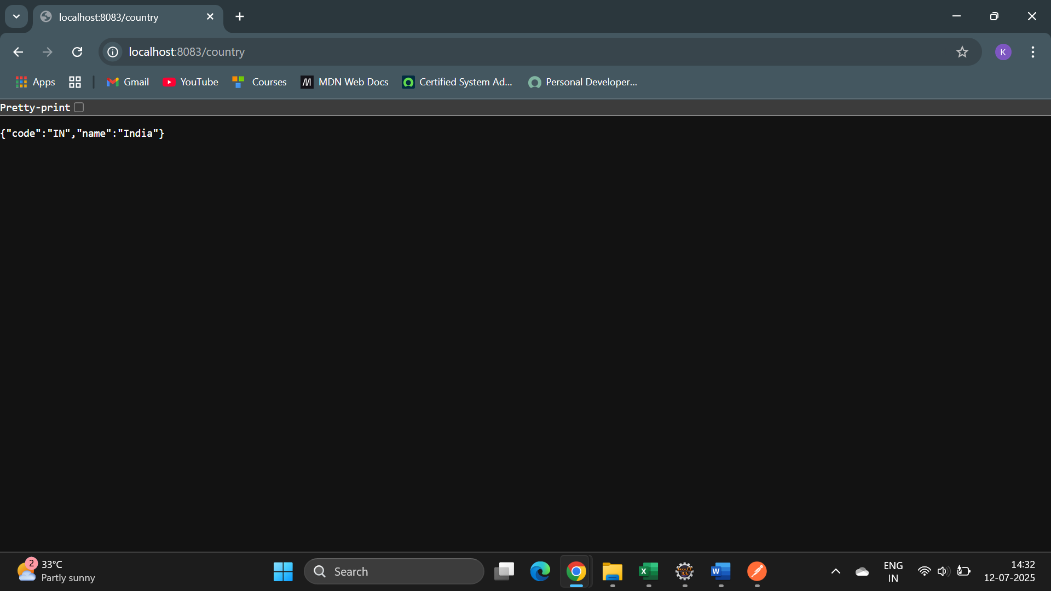

POSTMAN

